Experiment-7

Name-Nilabh Sharma

Sap id: - 500120183

Batch -1

Lab 7

create database lab7;

use lab7;

CREATE TABLE employee ( emp_id INT PRIMARY KEY, fname VARCHAR(50), lname VARCHAR(50), ssn CHAR(9), bdate DATE, address VARCHAR(100), sex CHAR(1), salary DECIMAL(10, 2), super_ssn CHAR(9), dno INT );

CREATE TABLE department ( dnumber INT PRIMARY KEY, dname VARCHAR(50), mgr_ssn CHAR(9), mgr_start_date DATE );

CREATE TABLE project ( pnumber INT PRIMARY KEY, pname VARCHAR(50), plocation VARCHAR(50), dnum INT );

CREATE TABLE works_on ( emp_id INT, pno INT, hours DECIMAL(4, 1), PRIMARY KEY (emp_id, pno) );

CREATE TABLE dependent ( emp_id INT, dependent_name VARCHAR(50), sex CHAR(1), bdate DATE, relationship VARCHAR(50), PRIMARY KEY (emp_id, dependent_name) );

INSERT INTO employee (emp_id, fname, lname, ssn, bdate, address, sex, salary, super_ssn, dno) VALUES (1, 'John', 'Smith', '123456789', '1980-06-09', '123 Apple St', 'M', 50000, '333445555', 5), (2, 'Franklin', 'Wong', '987654321', '1978-02-17', '456 Orange St', 'M', 60000, NULL, 1), (3, 'Aayush', 'Kharb', '888888888', '2002-07-01', '789 Mango St', 'M', 45000, '987654321', 3);

INSERT INTO department (dnumber, dname, mgr_ssn, mgr_start_date) VALUES (5, 'Research', '333445555', '2021-01-01'), (1, 'Administration', '987654321', '2019-07-01');

INSERT INTO project (pnumber, pname, plocation, dnum) VALUES (101, 'ProductX', 'Houston', 5), (102, 'ProductY', 'San Francisco', 1);

INSERT INTO works_on (emp_id, pno, hours) VALUES (1, 101, 12), (2, 102, 8);

INSERT INTO dependent (emp_id, dependent_name, sex, bdate, relationship) VALUES (1, 'John', 'M', '2005-09-01', 'Son'), (2, 'Sophia', 'F', '2008-05-10', 'Daughter');

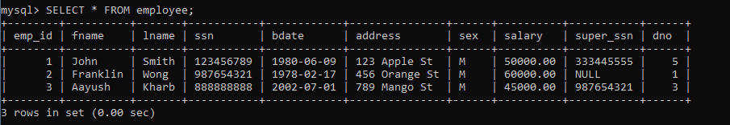

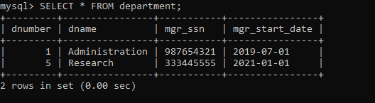

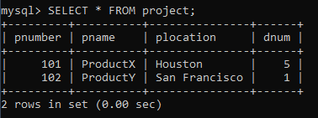

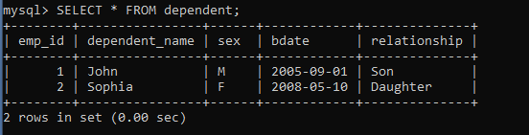

**QUERRIES ANSWER**

select e.fname, e.lname from employee e join works_on w on e.emp_id = w.emp_id join project p on w.pno = p.pnumber where e.dno = 5 and p.pname = 'productx' and w.hours > 10;

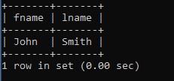

select e.fname, e.lname from employee e join dependent d on e.emp_id = d.emp_id where e.fname = d.dependent_name;

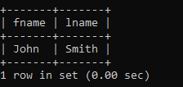

select e.fname, e.lname from employee e join employee s on e.super_ssn = s.ssn where s.fname = 'franklin' and s.lname = 'wong';

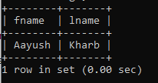

select e.fname, e.lname from employee e where not exists (select p.pnumber from project p where not exists (select w.pno from works_on w where w.emp_id = e.emp_id and w.pno = p.pnumber));



select e.fname, e.lname from employee e left join works_on w on e.emp_id = w.emp_id where w.emp_id is null;

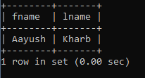

select distinct e.fname, e.lname, e.address from employee e join works_on w on e.emp_id = w.emp_id join project p on w.pno = p.pnumber join department d on e.dno = d.dnumber where p.plocation = 'houston' and d.dnumber <> p.dnum;



select e.lname from employee e join department d on e.ssn = d.mgr_ssn left join dependent dep on e.emp_id = dep.emp_id where dep.emp_id is null;

